Task – 18/09/2020

**Task 1 : Reactive Forms**

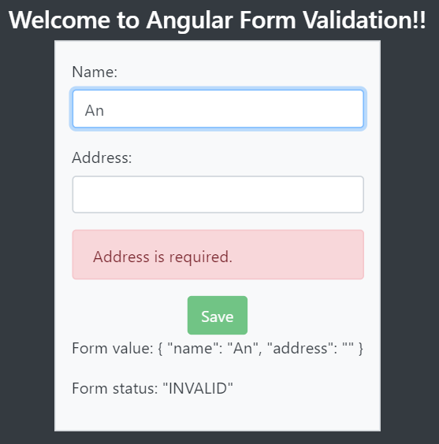

app.module.ts  
---------------------------------------------------------------------------------------------------------------------------------------

import { BrowserModule } from '@angular/platform-browser';

import { NgModule } from '@angular/core';

import { FormsModule, ReactiveFormsModule } from '@angular/forms'

import { AppRoutingModule } from './app-routing.module';

import { AppComponent } from './app.component';

import { MyComponentComponent } from './my-component/my-component.component';

@NgModule({

  declarations: [

    AppComponent,

    MyComponentComponent

  ],

  imports: [

    BrowserModule,

    AppRoutingModule,

    FormsModule,

    ReactiveFormsModule

  ],

  providers: [],

  bootstrap: [AppComponent]

})

export class AppModule { }

my-component.component.ts  
---------------------------------------------------------------------------------------------------------------------------------------

import { Component, OnInit } from '@angular/core';

import { FormGroup,  FormBuilder,  Validators } from '@angular/forms';

@Component({

  selector: 'app-my-component',

  templateUrl: './my-component.component.html',

  styleUrls: ['./my-component.component.css']

})

export class MyComponentComponent implements OnInit {

  title = 'Angular Form Validation';

  angForm: FormGroup;

  constructor(private fb: FormBuilder) {

    this.angForm = this.fb.group({

      name: ['', Validators.required ],

      address: ['', Validators.required ]

    });

  }

  ngOnInit(): void {

  }

}

---------------------------------------------------------------------------------------------------------------------------------------

my-component.component.html  
---------------------------------------------------------------------------------------------------------------------------------------

<div class="p-3 mb-2 bg-dark text-white">

    <div class="d-flex justify-content-center" style="padding-top: 10px;">

        <h4>Welcome to {{title}}!!</h4>

    </div>

    <div class="d-flex justify-content-center">

        <form [formGroup]="angForm" novalidate class="border  p-3 mb-2 bg-light text-dark" style="padding: 10px;">

            <div class="form-group">

                <label>Name:</label>

                <input class="form-control" formControlName="name" type="text">

            </div>

            <div *ngIf="angForm.controls['name'].invalid && (angForm.controls['name'].dirty || angForm.controls['name'].touched)" class="alert alert-danger">

                <div *ngIf="angForm.controls['name'].errors.required">Name is required.</div>

            </div>

            <div class="form-group">

               <label>Address:</label>

               <input class="form-control" formControlName="address" type="text">

            </div>

            <div *ngIf="angForm.controls['address'].invalid && (angForm.controls['address'].dirty || angForm.controls['address'].touched)" class="alert alert-danger">

                <div *ngIf="angForm.controls['address'].errors.required">Address is required.</div>

            </div>

            <div class="d-flex justify-content-center">

                <button type="submit" [disabled]="angForm.pristine || angForm.invalid" class="center btn btn-success">Save</button>

            </div>

            <p>Form value: {{ angForm.value | json }}</p>

            <p>Form status: {{ angForm.status | json }}</p>

        </form>

        <br /> {}

    </div>

</div>

---------------------------------------------------------------------------------------------------------------------------------------

**Task 2 : Live Virtual Class App**

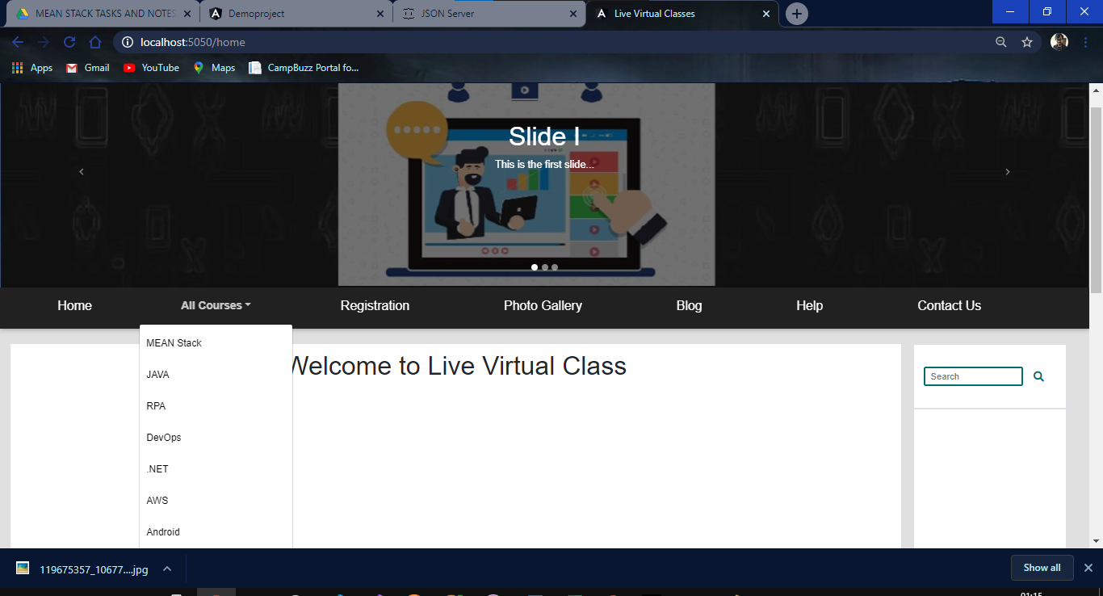

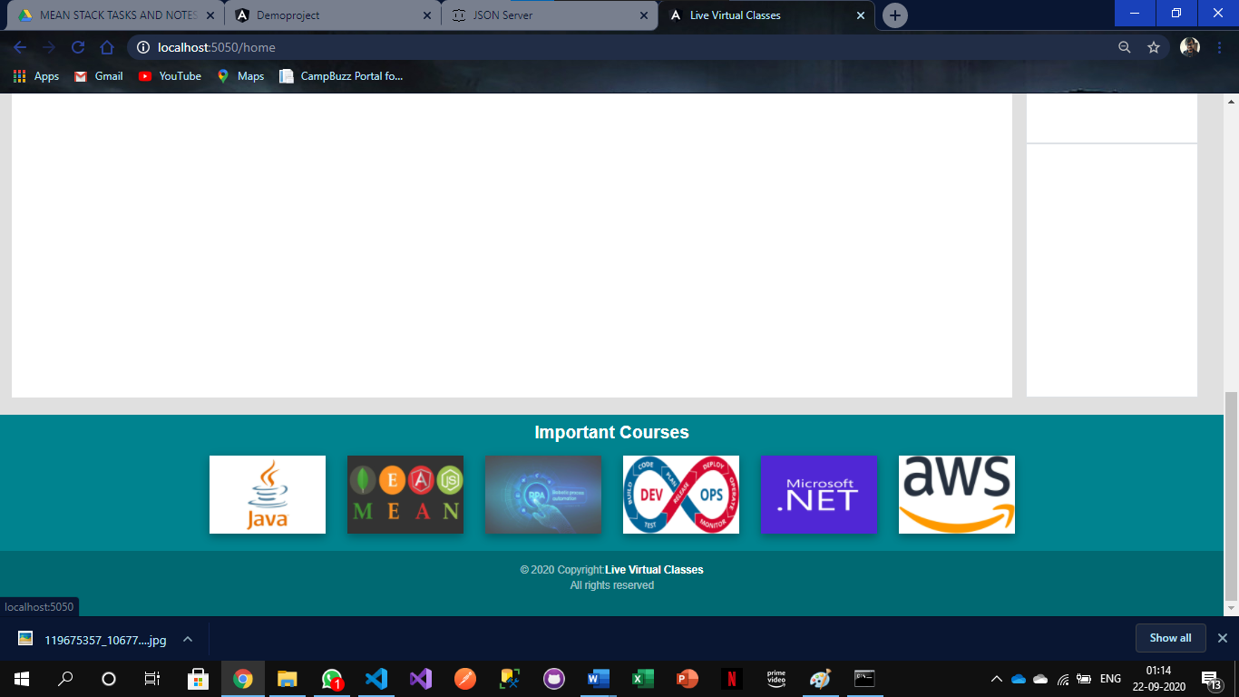

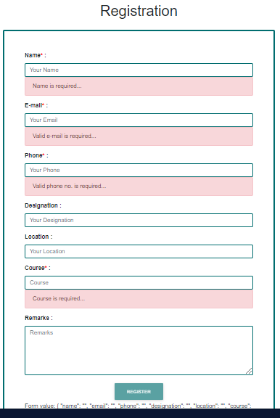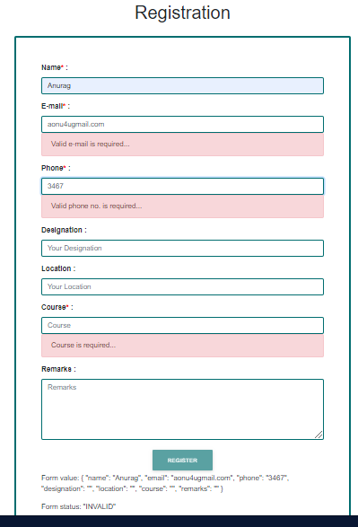 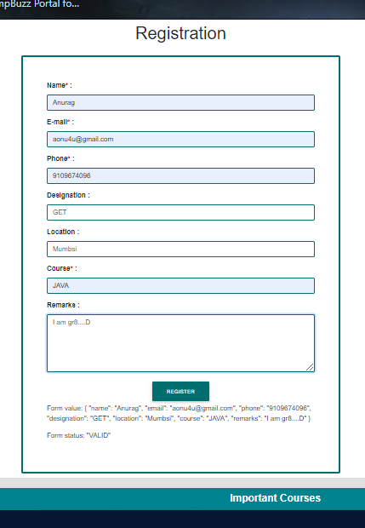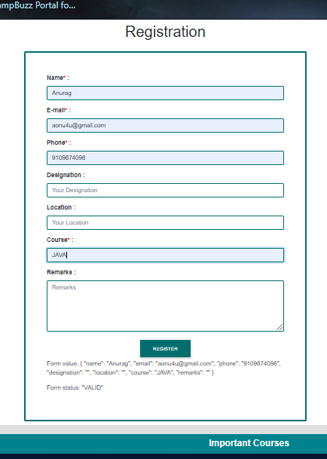

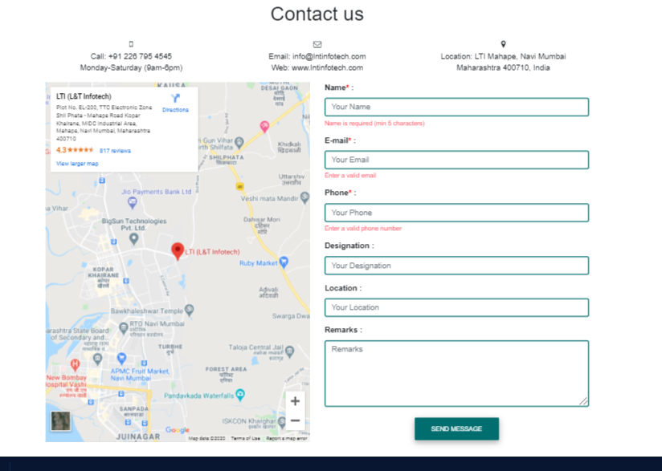

app.module.ts  
---------------------------------------------------------------------------------------------------------------------------------------

import { BrowserModule } from '@angular/platform-browser';

import { NgModule } from '@angular/core';

import { routes } from './app.router';

import { AppRoutingModule } from './app-routing.module';

import { AppComponent } from './app.component';

import { HomeComponent } from './Component/home/home.component';

import { RegistrationComponent } from './Component/registration/registration.component';

import { PhotoGalleryComponent } from './Component/photo-gallery/photo-gallery.component';

import { BlogComponent } from './Component/blog/blog.component';

import { HelpComponent } from './Component/help/help.component';

import { ContactUsComponent } from './Component/contact-us/contact-us.component';

import { FormsModule, ReactiveFormsModule } from '@angular/forms';

@NgModule({

  declarations: [

    AppComponent,

    HomeComponent,

    RegistrationComponent,

    PhotoGalleryComponent,

    BlogComponent,

    HelpComponent,

    ContactUsComponent

  ],

  imports: [

    BrowserModule,

    AppRoutingModule,

    routes,

    FormsModule,

    ReactiveFormsModule

  ],

  providers: [],

  bootstrap: [AppComponent]

})

export class AppModule { }

---------------------------------------------------------------------------------------------------------------------------------------

app.router.ts  
---------------------------------------------------------------------------------------------------------------------------------------

import { Routes, RouterModule } from '@angular/router';

import { ModuleWithProviders } from '@angular/compiler/src/core';

import { HomeComponent } from './Component/home/home.component';

import { RegistrationComponent } from './Component/registration/registration.component';

import { PhotoGalleryComponent } from './Component/photo-gallery/photo-gallery.component';

import { BlogComponent } from './Component/blog/blog.component';

import { HelpComponent } from './Component/help/help.component';

import { ContactUsComponent } from './Component/contact-us/contact-us.component';

export const router:Routes = [

    { path:'',redirectTo:'home',pathMatch:'full' },

    { path:'home',component:HomeComponent },

    { path:'registration',component:RegistrationComponent },

    { path:'photo-gallery',component:PhotoGalleryComponent },

    { path:'blog',component:BlogComponent },

    { path:'help',component:HelpComponent },

    { path:'contact-us',component:ContactUsComponent }

];

export const routes:ModuleWithProviders = RouterModule.forRoot(router);

---------------------------------------------------------------------------------------------------------------------------------------

app.component.ts  
---------------------------------------------------------------------------------------------------------------------------------------

import { Component } from '@angular/core';

@Component({

  selector: 'app-root',

  templateUrl: './app.component.html',

  styleUrls: ['./app.component.css']

})

export class AppComponent {

  carousel_img:any = {

    img1url:"assets/img/c1.jpg",

    img2url:"assets/img/c2.jpg",

    img3url:"assets/img/c3.jpg"

  };

  important_courses_img = {

    img1url:"assets/img/p1.jpg",

    img2url:"assets/img/p2.jpg",

    img3url:"assets/img/p3.jpg",

    img4url:"assets/img/p4.png",

    img5url:"assets/img/p5.png",

    img6url:"assets/img/p6.jpg",

  };

}

app.component.html  
---------------------------------------------------------------------------------------------------------------------------------------

<header>

    <div id="carouselExampleIndicators" class="carousel slide" data-ride="carousel">

        <ol class="carousel-indicators">

          <li data-target="#carouselExampleIndicators" data-slide-to="0" class="active"></li>

          <li data-target="#carouselExampleIndicators" data-slide-to="1"></li>

          <li data-target="#carouselExampleIndicators" data-slide-to="2"></li>

        </ol>

        <div class="carousel-inner" >

            <div class="carousel-item active">

                <img class="d-block w-100" [src]="carousel_img.img1url" alt="First slide">

                <div class="carousel-caption d-none d-md-block" style="top: 80px;bottom: auto;">

                    <h1>Slide I</h1>

                    <p>This is the first slide...</p>

                </div>

            </div>

            <div class="carousel-item" >

                <img class="d-block w-100" [src]="carousel_img.img2url" alt="Second slide">

                <div class="carousel-caption d-none d-md-block" style="top: 80px;bottom: auto;">

                    <h1>Slide II</h1>

                    <p>This is the secong slide...</p>

                </div>

            </div>

            <div class="carousel-item" >

                <img class="d-block w-100" [src]="carousel_img.img3url" alt="Third slide">

                <div class="carousel-caption d-none d-md-block" style="top: 80px;bottom: auto;">

                    <h1>Slide III</h1>

                    <p>This is the third slide...</p>

                </div>

            </div>

        </div>

        <a class="carousel-control-prev" href="#carouselExampleIndicators" role="button" data-slide="prev">

            <span class="carousel-control-prev-icon" aria-hidden="true"></span>

            <span class="sr-only">Previous</span>

        </a>

        <a class="carousel-control-next" href="#carouselExampleIndicators" role="button" data-slide="next">

            <span class="carousel-control-next-icon" aria-hidden="true"></span>

            <span class="sr-only">Next</span>

        </a>

    </div>

    <nav class="navbar navbar-expand-lg navbar-dark bg-dark">

        <button class="navbar-toggler" type="button" data-toggle="collapse" data-target="#navbarNavDropdown" aria-controls="navbarNavDropdown" aria-expanded="false" aria-label="Toggle navigation">

            <span class="navbar-toggler-icon"></span>

        </button>

        <div class="collapse navbar-collapse" id="navbarNavDropdown">

            <ul class="navbar-nav">

                <li class="nav-item">

                    <a class="nav-link" [routerLink]="['home']"><h5 style="padding-left: 65px; padding-right: 65px;">Home</h5><span class="sr-only">(current)</span></a>

                </li>

                <li class="nav-item dropdown">

                    <a class="nav-link dropdown-toggle font-weight-bold" style="font-size: 17px; padding-left: 65px; padding-right: 65px;" id="navbarDropdownMenuLink" role="button" data-toggle="dropdown" aria-haspopup="true" aria-expanded="false">All Courses</a>

                    <div class="dropdown-menu" aria-labelledby="navbarDropdownMenuLink">

                        <a class="dropdown-item" href="#">MEAN Stack</a>

                        <a class="dropdown-item" href="#">JAVA</a>

                        <a class="dropdown-item" href="#">RPA</a>

                        <a class="dropdown-item" href="#">DevOps</a>

                        <a class="dropdown-item" href="#">.NET</a>

                        <a class="dropdown-item" href="#">AWS</a>

                        <a class="dropdown-item" href="#">Android</a>

                    </div>

                </li>

                <li class="nav-item">

                    <a class="nav-link" [routerLink]="['registration']"><h5 style="padding-left: 65px; padding-right: 65px;">Registration</h5></a>

                </li>

                <li class="nav-item">

                    <a class="nav-link" [routerLink]="['photo-gallery']"><h5 style="padding-left: 65px; padding-right: 65px;">Photo Gallery</h5></a>

                </li>

                <li class="nav-item">

                    <a class="nav-link" [routerLink]="['blog']"><h5 style="padding-left: 65px; padding-right: 65px;">Blog</h5></a>

                </li>

                <li class="nav-item">

                    <a class="nav-link" [routerLink]="['help']"><h5 style="padding-left: 65px; padding-right: 65px;">Help</h5></a>

                </li>

                <li class="nav-item">

                    <a class="nav-link" [routerLink]="['contact-us']"><h5 style="padding-left: 65px; padding-right: 65px;">Contact Us</h5></a>

                </li>

            </ul>

        </div>

    </nav>

</header>

<br>

<div class="row mx-md-3">

    <div class="col-sm-10 col-lg-10 col-md-10 col-xs-10 bg-white" style="padding: 10px;">

        <router-outlet></router-outlet>

    </div>

    <div class="col-sm-2 col-lg-2 col-md-2 col-xs-2">

        <div class="row mx-md-1 bg-white d-flex justify-content-center border" style="height: 100px;">

            <form class="form-inline active-cyan-4" style="margin: 15px;">

                <input class="form-control form-control-sm mr-3 w-75" type="text" style="border: 3px solid#006D6F;" placeholder="Search" aria-label="Search" />

                <i class="fas fa-search" style="color: #006D6F;" aria-hidden="true" ></i>

            </form>

        </div>

        <div class="row mx-md-1 bg-white d-flex justify-content-center border" style="height: 500px">

        </div>

        <div class="row mx-md-1 bg-white d-flex justify-content-center border" style="height:350px">

        </div>

    </div>

</div>

<br>

<!-- Footer -->

<footer class="page-footer font-small cyan darken-3">

    <!-- Footer Elements -->

  <div class="container">

    <div class="row d-flex justify-content-center" style="padding: 10px;">

        <h4 class="font-weight-bold">Important Courses</h4>

    </div>

    <!--Grid row-->

    <div class="row">

      <!--Grid column-->

      <div class="col-lg-2 col-md-12 mb-4">

        <!--Image-->

        <div class="view overlay z-depth-1-half">

          <img [src]="important_courses_img.img1url" class="img-fluid"

            alt="">

          <a href="">

            <div class="mask rgba-white-light"></div>

          </a>

        </div>

      </div>

      <!--Grid column-->

      <!--Grid column-->

      <div class="col-lg-2 col-md-6 mb-4">

        <!--Image-->

        <div class="view overlay z-depth-1-half">

          <img [src]="important_courses_img.img2url" class="img-fluid"

            alt="">

          <a href="">

            <div class="mask rgba-white-light"></div>

          </a>

        </div>

      </div>

      <!--Grid column-->

      <!--Grid column-->

      <div class="col-lg-2 col-md-6 mb-4">

        <!--Image-->

        <div class="view overlay z-depth-1-half">

          <img [src]="important_courses_img.img3url" class="img-fluid"

            alt="">

          <a href="">

            <div class="mask rgba-white-light"></div>

          </a>

        </div>

      </div>

      <!--Grid column-->

      <!--Grid column-->

      <div class="col-lg-2 col-md-12 mb-4">

        <!--Image-->

        <div class="view overlay z-depth-1-half">

          <img [src]="important_courses_img.img4url" class="img-fluid"

            alt="">

          <a href="">

            <div class="mask rgba-white-light"></div>

          </a>

        </div>

      </div>

      <!--Grid column-->

      <!--Grid column-->

      <div class="col-lg-2 col-md-6 mb-4">

        <!--Image-->

        <div class="view overlay z-depth-1-half">

          <img [src]="important_courses_img.img5url" class="img-fluid"

            alt="">

          <a href="">

            <div class="mask rgba-white-light"></div>

          </a>

        </div>

      </div>

      <!--Grid column-->

      <!--Grid column-->

      <div class="col-lg-2 col-md-6 mb-4">

        <!--Image-->

        <div class="view overlay z-depth-1-half">

          <img [src]="important_courses_img.img6url" class="img-fluid"

            alt="">

          <a href="">

            <div class="mask rgba-white-light"></div>

          </a>

        </div>

      </div>

      <!--Grid column-->

    </div>

    <!--Grid row-->

  </div>

  <!-- Footer Elements -->

    <!-- Copyright -->

    <div class="footer-copyright text-center py-3">&copy; 2020 Copyright:<span class="font-weight-bold text-white">Live Virtual Classes</span><p>All rights reserved</p></div>

    <!-- Copyright -->

  </footer>

  <!-- Footer -->

---------------------------------------------------------------------------------------------------------------------------------------

home.component.html  
---------------------------------------------------------------------------------------------------------------------------------------

<div class="row d-flex justify-content-center" style="margin-bottom: 50px;">

    <h1>Welcome to Live Virtual Class</h1>

</div>

---------------------------------------------------------------------------------------------------------------------------------------

registration.component.ts  
---------------------------------------------------------------------------------------------------------------------------------------

import { Component, OnInit } from '@angular/core';

import { FormGroup, FormBuilder, Validators } from '@angular/forms';

@Component({

  selector: 'app-registration',

  templateUrl: './registration.component.html',

  styleUrls: ['./registration.component.css']

})

export class RegistrationComponent implements OnInit {

  registrationForm:FormGroup;

  constructor(private fb:FormBuilder) {

    this.registrationForm = this.fb.group({

      name: ['', Validators.required],

      email: ['', [Validators.email,Validators.required]],

      phone: ['', [Validators.required,Validators.pattern("[0-9]{10}")]],

      designation: [''],

      location: [''],

      course: ['', Validators.required],

      remarks:['']

    });

  }

  ngOnInit(): void {

  }

}

---------------------------------------------------------------------------------------------------------------------------------------

registration.component.html  
---------------------------------------------------------------------------------------------------------------------------------------

<div class="container" style="margin-top: 20px;">

    <div class="row d-flex justify-content-center" style="margin-bottom: 20px;">

        <h1>Registration</h1>

    </div>

    <div class="row d-flex justify-content-center">

        <form [formGroup]="registrationForm" novalidate class="rounded" style="border: 5px solid  #006D6F; padding: 55px; width: 750px;">

            <div class="form-group">

                <label for="name" class="font-weight-bold">Name<span style="color: red;">* </span>:</label>

                <input type="text" name="name" class="form-control" formControlName="name" style="border: 2px solid #006D6F" id="name" placeholder="Your Name"/>

                <div *ngIf="registrationForm.controls['name'].invalid && ( registrationForm.controls['name'].dirty || registrationForm.controls['name'].touched ) " class="alert alert-danger">

                    <div *ngIf="registrationForm.controls['name'].errors.required">Name is required...</div>

                </div>

            </div>

            <div class="form-group">

                <label for="email" class="font-weight-bold">E-mail<span style="color: red;">* </span>:</label>

                <input type="email" class="form-control" formControlName="email" style="border: 2px solid #006D6F" name="email" id="email" placeholder="Your Email"/>

                <div *ngIf="registrationForm.controls['email'].invalid && ( registrationForm.controls['email'].dirty || registrationForm.controls['email'].touched ) " class="alert alert-danger">Valid e-mail is required...</div>

            </div>

            <div class="form-group">

                <label for="phone" class="font-weight-bold">Phone<span style="color: red;">* </span>:</label>

                <input type="text" class="form-control" formControlName="phone" style="border: 2px solid #006D6F" name="phone" id="phone" placeholder="Your Phone"/>

                <div *ngIf="registrationForm.controls['phone'].invalid && ( registrationForm.controls['phone'].dirty || registrationForm.controls['phone'].touched ) " class="alert alert-danger">Valid phone no. is required...</div>

            </div>

            <div class="form-group">

                <label for="designation" class="font-weight-bold">Designation :</label>

                <input type="text" class="form-control" formControlName="designation" style="border: 2px solid #006D6F" name="designation" id="designation" placeholder="Your Designation" />

            </div>

            <div class="form-group">

                <label for="location" class="font-weight-bold">Location :</label>

                <input type="text" class="form-control" formControlName="location" style="border: 2px solid #006D6F" name="location" id="location" placeholder="Your Location"/>

            </div>

            <div class="form-group">

                <label for="course" class="font-weight-bold">Course<span style="color: red;">* </span>:</label>

                <input type="text" name="course" class="form-control" formControlName="course" style="border: 2px solid #006D6F" id="course" placeholder="Course"/>

                <div *ngIf="registrationForm.controls['course'].invalid && ( registrationForm.controls['course'].dirty || registrationForm.controls['course'].touched ) " class="alert alert-danger">

                    <div *ngIf="registrationForm.controls['course'].errors.required">Course is required...</div>

                </div>

            </div>

            <div class="form-group">

                <label for="remarks" class="font-weight-bold">Remarks :</label>

                <textarea class="form-control" formControlName="remarks" style="border: 2px solid #006D6F" name="remarks" id="remarks" rows="5" placeholder="Remarks"></textarea>

            </div>

            <div class="text-center"><button [disabled]="registrationForm.pristine || registrationForm.invalid" class="btn text-white" style="background-color: #006D6F;" type="submit">Register</button></div>

            <p>Form value: {{ registrationForm.value | json }}</p>

            <p>Form status: {{ registrationForm.status | json }}</p>

        </form>

    </div>

</div>

---------------------------------------------------------------------------------------------------------------------------------------

contact-us.component.ts  
---------------------------------------------------------------------------------------------------------------------------------------

import { Component, OnInit } from '@angular/core';

@Component({

  selector: 'app-contact-us',

  templateUrl: './contact-us.component.html',

  styleUrls: ['./contact-us.component.css']

})

export class ContactUsComponent implements OnInit {

  contactform;

  constructor() { }

  ngOnInit(): void {

    this.contactform = {

      name:'',

      email:'',

      phone:'',

      designation:'',

      location:'',

      remarks:''

    };

  }

  save(model:any,isValid:boolean){

    console.log(model,isValid);

  }

}

---------------------------------------------------------------------------------------------------------------------------------------

contact-us.component.html  
---------------------------------------------------------------------------------------------------------------------------------------

<div class="row d-flex justify-content-center" style="margin-bottom: 50px;">

<!-- ======= Contact Section ======= -->

      <div class="container ">

        <div class="row" style="margin-bottom: 20px;">

          <div class="col-md-12 col-sm-12 col-xs-12">

            <div class="section-headline text-center">

              <h1>Contact us</h1>

            </div>

          </div>

        </div>

        <div class="row">

          <!-- Start contact icon column -->

          <div class="col-md-4 col-sm-4 col-xs-12">

            <div class="contact-icon text-center">

              <div class="single-icon">

                <i class="fa fa-mobile"></i>

                <p>

                  Call: +91 226 795 4545<br>

                  <span>Monday-Saturday (9am-6pm)</span>

                </p>

              </div>

            </div>

          </div>

          <!-- Start contact icon column -->

          <div class="col-md-4 col-sm-4 col-xs-12">

            <div class="contact-icon text-center">

              <div class="single-icon">

                <i class="fa fa-envelope-o"></i>

                <p>

                  Email: info@lntinfotech.com<br>

                  <span>Web: www.lntinfotech.com</span>

                </p>

              </div>

            </div>

          </div>

          <!-- Start contact icon column -->

          <div class="col-md-4 col-sm-4 col-xs-12">

            <div class="contact-icon text-center">

              <div class="single-icon">

                <i class="fa fa-map-marker"></i>

                <p>

                  Location: LTI Mahape, Navi Mumbai<br>

                  <span>Maharashtra 400710, India</span>

                </p>

              </div>

            </div>

          </div>

        </div>

        <div class="row">

          <!-- Start Google Map -->

          <div class="col-md-6 col-sm-6 col-xs-12">

            <!-- Start Map -->

            <iframe src="https://maps.google.com/maps?q=lti%20mahape&t=&z=13&ie=UTF8&iwloc=&output=embed" width="100%" height="100%" frameborder="0" style="border:0" allowfullscreen></iframe>

            <!-- End Map -->

          </div>

          <!-- End Google Map -->

          <!-- Start  contact -->

          <div class="col-md-6 col-sm-6 col-xs-12">

              <form #f="ngForm" novalidate (ngSubmit)="save(f.value,f.valid)">

                <div class="form-group ">

                  <label for="name" class="font-weight-bold">Name<span style="color: red;">* </span>:</label>

                  <input type="text" name="name" class="form-control" style="border: 2px solid #006D6F" id="name" placeholder="Your Name" [(ngModel)]="contactform.name" #name="ngModel" required minlength="5"/>

                  <small class="form-text text-danger" [hidden]="name.valid || (name.pristine && !f.submitted)">Name is required (min 5 characters)</small>

                </div>

                <div class="form-group">

                  <label for="email" class="font-weight-bold">E-mail<span style="color: red;">* </span>:</label>

                  <input type="email" class="form-control" style="border: 2px solid #006D6F" name="email" id="email" placeholder="Your Email" [(ngModel)]="contactform.email" #email="ngModel" required/>

                  <small class="form-text text-danger" [hidden]="email.valid || (email.pristine && !f.submitted)">Enter a valid email</small>

                </div>

                <div class="form-group">

                  <label for="phone" class="font-weight-bold">Phone<span style="color: red;">* </span>:</label>

                  <input type="text" class="form-control" style="border: 2px solid #006D6F" name="phone" id="phone" placeholder="Your Phone" [ngModel]="contactform.phone" #phone="ngModel" pattern="[0-9]{10}" required/>

                  <small class="form-text text-danger" [hidden]="phone.valid || (phone.pristine && !f.submitted)">Enter a valid phone number</small>

                </div>

                <div class="form-group">

                  <label for="designation" class="font-weight-bold">Designation :</label>

                  <input type="text" class="form-control" style="border: 2px solid #006D6F" name="designation" id="designation" placeholder="Your Designation" [(ngModel)]="contactform.designation" #designation="ngModel"/>

                </div>

                <div class="form-group">

                  <label for="location" class="font-weight-bold">Location :</label>

                  <input type="text" class="form-control" style="border: 2px solid #006D6F" name="location" id="location" placeholder="Your Location" [(ngModel)]="contactform.location" #location="ngModel"/>

                </div>

                <div class="form-group">

                  <label for="remarks" class="font-weight-bold">Remarks :</label>

                  <textarea class="form-control" style="border: 2px solid #006D6F" name="remarks" rows="5"  placeholder="Remarks" [(ngModel)]="contactform.remarks" #remarks="ngModel"></textarea>

                </div>

            <div class="text-center">

              <button class="btn text-white" style="background-color: #006D6F;" type="submit">Send Message</button>

            </div>

              </form>

          </div>

          <!-- End Left contact -->

        </div>

      </div>

---------------------------------------------------------------------------------------------------------------------------------------